Smart water fountain

Program:

import machine

import time

TRIGGER_PIN = 23

ECHO_PIN = 22

LEAK_LED_PIN = 19

trigger = machine.Pin(TRIGGER_PIN, machine.Pin.OUT)

echo = machine.Pin(ECHO_PIN, machine.Pin.IN)

leak_led = machine.Pin(LEAK_LED_PIN, machine.Pin.OUT)

def measure_distance():

    trigger.value(0)

    time.sleep_us(5)

    trigger.value(1)

    time.sleep_us(10)

    trigger.value(0)

    pulse_start = pulse_end = 0

    while echo.value() == 0:

        pulse_start = time.ticks_us()

    while echo.value() == 1:

        pulse_end = time.ticks_us()

    pulse_duration = pulse_end - pulse_start

    distance = (pulse_duration * 0.0343) / 2

    return distance

def check_for_leak():

    distance = measure_distance()

    threshold_distance = 10

Sensors :

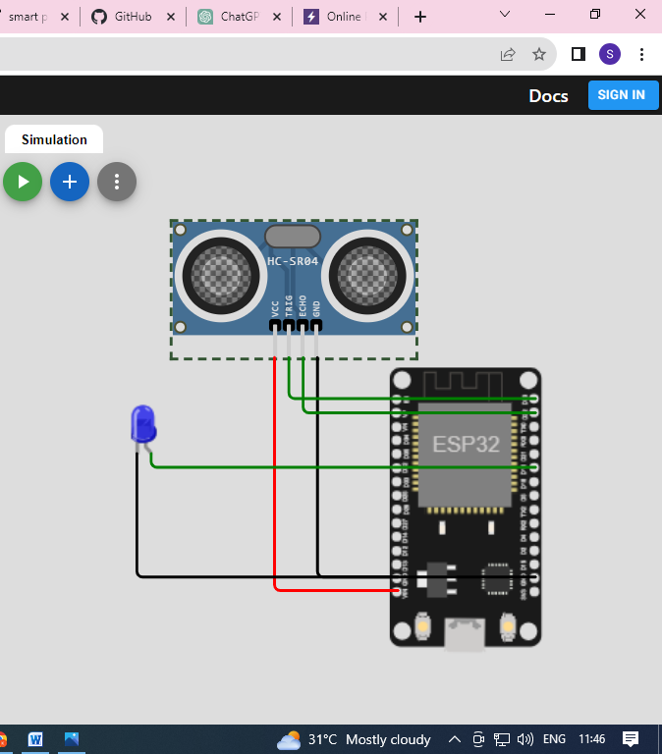

Output :

